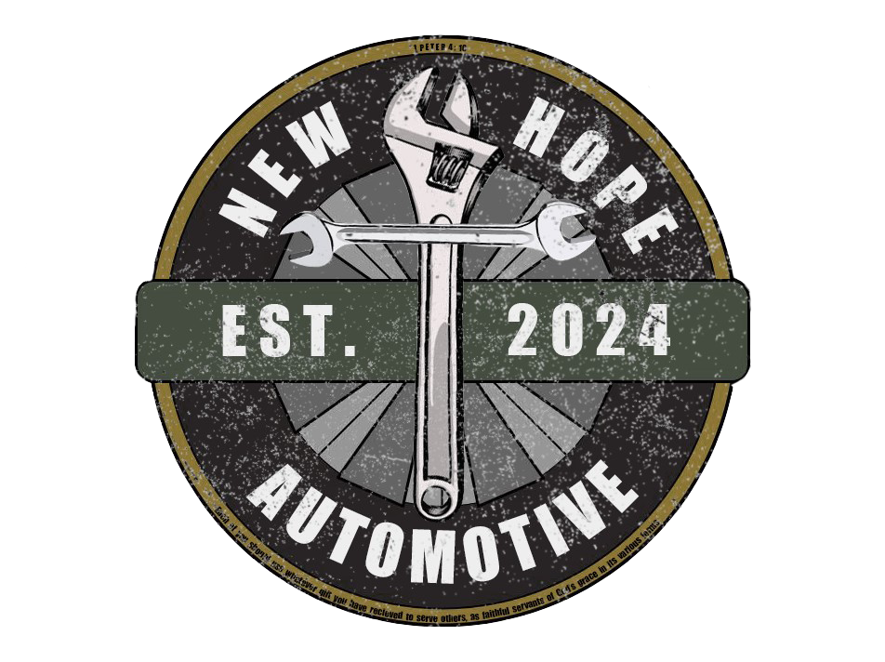**Income Eligibility Verification**

**_______________________________________________________________**

| Client Name and Contact Information |  |
| --- | --- |
| Number of Persons in Household |  |
| Gross Annual Income**\*** |  |

***\*****Annual Income is based on the most recent 30-day period, projected for the next 12 months. Income sources terminated in the last month do not need to be included in this calculation.*

**Instructions for Case Manager/Third Party Verifying Income:** *Note: the client MUST call New Hope Automotive for an appointment. We do not need this form completed until the date of their appointment. We will not call them upon receipt of this form.*

This form is to certify that the income received by the above named individual does not exceed the following income eligibility guidelines for services from New Hope Automotive:

| **Federal Poverty Guidelines 2024 (150%)** | | | |
| --- | --- | --- | --- |
| **Persons in Household** | **Annually** | **Monthly** | **Weekly** |
| 1 | $22,590 | $1,882 | $470 |
| 2 | $30,660 | $2,555 | $639 |
| 3 | $38,730 | $3,227 | $807 |
| 4 | $46,800 | $3,900 | $975 |
| 5 | $54,870 | $4,572 | $1143 |
| 6 | $62,940 | $5,245 | $1311 |

**Documentation of Client Income:** New Hope Automotive expects that third parties completing this form will maintain source documents used to determine income for clients who are planning to be customers at the Lift (following your agency’s retention policies). We do not require that you submit this documentation, only this signed Certification of Income Eligibility.

Certification of Client Income Eligibility:

I certify that the household of _____________________ is at/below 150% of Federal Poverty Guidelines.

__________________________________ _____________ _________________________

**Case Manager / Agency Staff Signature** **Date** **Referral Agency Name**

RETURN FORM TO: incomeverification@newhopeautomotive.org 734-732-3204 (phone)

855 Aspen Woods Trl, Brighton, MI 48114 WE DO NOT HAVE A FAX